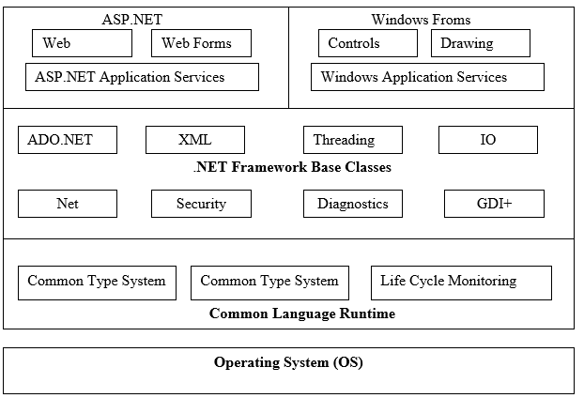

Dot Net Framework Structure

The .Net architecture is basically divided in to three layers namely top, middle and bottom layer. The bottom layer is CLR, it is the heart of .NET Framework which provides the runtime environment in which programs are executed. The middle layer comprises the next generation of standard system services are brought under the control of the framework, making them universally available and standardizing their usage across languages.
.NET Framework sits on top of the operating system.
At the base of the .NET Framework is the Common Language Runtime (CLR). The CLR is the engine that manages the execution of the code.
The next layer up is the .NET Framework Base Classes. This layer contains classes, value types, and interfaces that you will use often in your development process. Most notably within the .NET Framework Base Classes is ADO.NET, which provides access to and management of data.
The third layer of the framework is ASP.NET and Windows Forms.
The second part of the top layer of the .NET Framework is the Windows Forms section. This is where you can build the traditional executable applications that you built with Visual Basic 6.0 in the past.
Advantages of Dot Net
1. ASP.NET reduces the line of code needed to develop large applications.
2. Built-in Windows authentication and per-application configuration keep your applications secured.
3. It is an ideal server-side scripting technology that is why code runs on the windows server before displaying on the web browser.
4. The ASP code and HTML smoothly mix with each other to generate dynamic web pages.
5. Dot NET framework is language independent, so choose any programming language that best suited to develop your application.
6. ASP.NET is easy to deploy because of built-in configuration information.
7. The Windows Web server precisely monitors the web pages, various components and application running over it. It immediately gives an alert for any memory leaks, unbounded loops and other illegal behaviors. It instantly kills those behaviors and restarts automatically.
8. Early binding, JIT compilation, caching services, and native optimization supports to get high level of performance.
9. All the application processes are minutely monitored and manage to help application continuously available to handle requests.

Based on server side scripting technology, which is why the code is processed on the windows server before it is displayed in the web browser. Therefore, ASP.net applications execute more quickly than interpreted scripts.
With ASP.NET, on-the-fly updates of deployed web applications are possible. This does not need the restarting of the server.
Additionally, ASP.Net provides automatic state management for web page controls. This is also called server controls. ASP.Net also offers the ability to create new as well as customized server controls from existing controls.
ASP.NET also provides built-in features for caching frequently requested web pages on the server. Additional features provided are localizing content for specific languages as well as cultures and even detecting browser capabilities.
ASP.NET also provides full support for XML, CSS and other new as well as established web standards.
For the program logic, a developer can choose to write the code in more than 25 .NET languages. This includes C#, Jscript, VB.Net, etc.

Definition of Dot Net:
A collection of tools, technologies and languages to work together in a framework to provide solutions to easily build and deploy robust applications that are able to easily communicate with one another and provide information and application logic, regardless of platforms and languages.
.Net is a new framework for developing web-based and windows-based applications within the Microsoft environment.
It moves application development from client-centric to server-centric.
In other words:
NET is not a language (Runtime and a library for writing and executing written programs in any compliant language)

Features of ASP .Net
- Cross-platform & container suppot:
With the introduction of .NET Core, you can now create ASP.NET applications and deploy them to Windows, Linux, and macOS. Microsoft and the community have put a huge effort into making Linux a first-class citizen for running ASP.NET.
Containers are eating the clouds these days. Docker, Kuberenetes and other technologies are all the rage. ASP.NET Core allows developers to utilize all of these new technologies. Microsoft Azure even has support for deploying your application to containers and Kubernetes.

High performance
Some say that performance is a critical feature of your software. I tend to agree! With the introduction of ASP.NET Core and the Kestrel web server, ASP.NET is touted as one of the fastest web application frameworks available. TechEmpower has some cool benchmarks you can check out.
The technology that powered the ASP.NET integrated pipeline and IIS was roughly 15 years old. It did everything and carried a lot of baggage with it.
- Asynchronous via async/await
ASP.NET has excellent support for utilizing asynchronous programming patterns. Async is now implemented in all common .NET Framework classes and most third-party libraries. Most modern applications spend most of their time and CPU cycles waiting for database queries, web service calls, and other I/O operations to complete.
- Unified MVC & Web API frameworks
Before ASP.NET Core, developers were most commonly using the MVC and Web API frameworks. MVC was tailored to creating web applications that served up HTML. Web API was designed to create RESTful services using JSON or XML.
With ASP.NET Core, MVC and Web API have been merged together. There was always a lot of overlap with the two frameworks. MVC could always return JSON data instead of HTML. Combining them was a good move and simplifies development.
- environments and development mode
One of my favorite features is the new environment feature. It allows you to easily differentiate parts of your code for their behavior in development, staging, production, etc. There was no standard way to do this before ASP.NET Core.
For example, it is used within your Startup.cs file to help configure your application. In this case, whether or not we want to show a more detailed exception page for development only.
- Dependency Injection
One of the great new features of ASP.NET Core is built in dependency injection. It is heavily used within ASP.NET MVC itself. It is the preferred way that things like logging contexts, database contexts, and other things are passed into your MVC controllers.

WebSockets And SignalR
ASP.NET has first class support for WebSockets. This can be used to persist long running connections and communicate back and forth with the browser. SignalR is a full framework that is also available that makes it easy handle common scenarios.
We use SignalR very heavily at Stackify. For example, when viewing the current monitoring data about one of your servers, every time we receive new data, we immediately push it to your browser so you can see it update in real time. These types of scenarios are perfect for WebSockets and SignalR makes it easy to do.

